C.V. RAMAN POLYTECHNIC

BHUBANESWAR



DIPLOMA

IN

COMPUTER SCIENCE & ENGG.

PROJECT ON-

“E­-BARBER”

**Under The Able Guidance Of**

MR. SAMBHU PRASAD PANDA

(ASST.PROF.CSE)

MR. PRADEEP RANJAN DHAL

(LECTURER)

SUBMITTED BY-

Abinash Barik (F19029007002)

Asish Kumar Barik (F19029007006)

DEPARTMENT OF COMPUTER SCIENCE & ENGINEERING

C.V. RAMAN POLYTRECHNIC, BBSR

BIDYANAGAR, MAHURA, JANLA, BHUBANESWAR-75054, ODISHA

ACADEMIC YEAR-2019-22

DEPARTMENT OF COMPUTER SCIENCE & ENGINEERING

C.V. RAMAN POLYTRECHNIC, BBSR

BIDYANAGAR, MAHURA, JANLA, BHUBANESWAR-75054, ODISHA

ACADEMIC YEAR-2019-22



CERTIFICATE

This is to certify that the project entitled “**E-BARBER**” efficient being submitted by Abinash Barik, Asish Kumar Barik, Vishal Raj, Aranda Prasad pattnaik, T Prabin Patra bearing registration No.F19029007002, F19029007006, F19029007005, F19029007028, F19029007030 in practical fulfilment of the requirement for the award of the degree of diploma in Computer Science and Engineering bonafided work carried out at C.V. Raman Polytechnic under my supervision.

**SIGNATURE OF STUDENTS HOD SEMINAR INCHARGE**

DEPARTMENT OF COMPUTER SCIENCE & ENGINEERING

C.V. RAMAN POLYTRECHNIC, BBSR

BIDYANAGAR, MAHURA, JANLA, BHUBANESWAR-75054, ODISHA

ACADEMIC YEAR-2019-22



ACKNOWLEDGEMENT

With immense please we, presenting “E-BARBER” project report as part of the curriculum of Diploma Engineering. I would like to express my special thanks of gratitude to Mr. Sambhu Prasad Panda for his able guidance and support in completing our project.

I express my profound thanks to Head of the Department, Mrs Prangya Paramita Mohapatra for her moral support and guidance. And all those who have indirectly guided and helped us in preparation of this project.

**SIGNATURE OF THE STUDENTS GUIDE**

C.V RAMAN POLYTECHNIC

BHUBANESWAR



**DECLARATION**

We hereby declare that the matter embodied in this is original and has not been submitted for the award of any other degree.

**SIGNATURE OF STUDENTS GUIDE SEMINAR INCHARGE**

**Abstract**

Searching out for the best barbershops or hair salons within your vicinity is a very tiresome task. Also, visiting a barbershop or salon without a prior appointment booking can keep you waiting in a queue thereby taking away your precious time. To solve this issue, we have developed an android based barbershop application. By entering a location this android app will generate a list of nearby barbershops & salons. Both the barbershop owners & users can access the application by registering themselves on the app by submitting the necessary details. The barbershop owners can update their profiles by adding photos & a list of services provided by them. The users can view the shops' profiles, photos & services, based on which they can book an appointment as per their desired time & date in their favourite shops. The users can also review & rate a shop through this app. This System can be used by barber shops & user who want to enjoy online bookings instead of waiting in a queue.

**Index**

1. Introduction
2. Key Features
3. Waterfall Model
4. System Analysis
5. Tree Structure of E-BARBER
6. Risk Management
7. Overview
8. Overall Description
9. Problems of current system
10. Requirement analysis
11. Non Functional requirements
12. Class Diagram
13. Use Case Diagram
14. Test Plan
15. Implementation
16. Limitations
17. Documentation
18. Conclusion
19. References

**INTRODUCTION**

Searching out for the best barbershops or hair salons within your vicinity is a very tiresome task. Also, visiting a barbershop or salon without a prior appointment booking can keep you waiting in a queue thereby taking away your precious time. To solve this issue, we have developed an android based barbershop application. By entering a location this android app will generate a list of nearby barbershops & salons.

Both the barbershop owners & users can access the application by registering themselves on the app by submitting the necessary details. The barbershop owners can update their profiles by adding photos & a list of services provided by them. The users can view the shops’ profiles, photos & services, based on which they can book an appointment as per their desired time & date in their favourite shops. The users can also review & rate a shop through this app.

Barber Application is used for booking barber services through android application. Admin is the authorized user who will verify Barber shop & its services. Admin can also block any barber account if needed. User can get a list of all the Barber shops nearby on Map and check and book its services. Barber can check the bookings and accordingly manage them. User can rate & review the shop & services.

**Key Features**

* Easy booking of various Salons.
* Easy search by venue, city and area.
* Option to choose from different Salons.
* Facility to go through reviews of different Salons.
* Live Seat/Advance Booking.
* Easy Booking and Easy Cancelation Policy.
* Fast Service and user friendly.
* Saloons/parlours will get costumers easily.

**Waterfall Model**

Operation and Maintenance

Testing & Integration

Implementation

Design

Requirements specification

Analysis

**System Analysis**

System analysis is a detailed study of the various operation performed by a system and their relationships within outside if the system. During analysis, data collected on the various files, decision point and transaction handled by the present system. The common used tools in the system are data flow diagram, interview etc. Training experience and common sense are required for collection of relevant information needed to develop the system.

System analysis can be categorized into three parts-

1. System planning and initial investigation.
2. Information gathering.
3. Applying analysis tools structured analysis.

**Tree Structure of E-BARBER**

E- BARBER

Home About us Log in / Sign up Subscription Contact Us

Search Near By Our Packages

Select a Category About Us Trail

Men Saloon Provider Bronze

Unsex Saloon Gold

Women Saloon User Platinum

**Risk Assessment and Management:**

* + - Before risk management begins it is imperative that a foundation is established for providing structured project information, thus, the following project elements were completed and defined prior to developing this Risk Management Plan:
    - Define work scope, schedule, resources, and cost elements
    - Develop project WBS/WBS dictionary
    - Develop master schedule and detailed schedules
    - Estimate project cost and finalize budget
    - Identify required and available resources
    - Establish performance measurement metrics
    - Define minimum and maximum baseline thresholds

Schedule

Resources

Cost

* + - Baseline reporting requirements

Format

Frequency of distribution

Distribution list

* + - Define Risk Management Roles and Responsibilities
    - Project Manager chairs the risk assessment meetings

Project team participates in risk assessment meetings and members serve as meeting recorder and timekeeper Key stakeholders participate in risk assessment meetings Project Sponsor may participate in risk assessment meetings.

**OVERVIEW**

This app is created for easy online booking of e-barber appointments has following tests

* Sign In
* Log In- Provider/ Customer
* Search Nearby barber shops.
* Choose the Barber shop according to you.
* Book your appointments.

**Sign In**:-

There is a quality sign in window because this is more secure than the other Sign in forms as in a normal Sing in window. A provider or a customer will first sign in the app, then he/she will able to use the app.

**Log In**:-

There is a quality log in window because this is more secure than other log in forms as in normal log in window there are multiple logins available so that more than one person can access to book appointments with their individual logins. But in this project there is only one login id i.e. provider or customer id and password by which a person enter the app and access the all services provided by ‘E-BAEBER’.

**Search nearby barber shops:-**

A customer will first search nearby barber shops. He/she check all shops reviews in our app/website. Then he/she will choose his/her favourite shop accordingly. A customer can book appointments with in a minute.

**Appointment Bookings:-**

After selecting a barber shop, a customer can book appointments effortlessly according to his/her time. Also the customer can cancel the booking before a specific time.

**Overall Description**

**Product Perspective:**

1. User Interface:-

The application will have a friendly and menu based interface. Following screens will be provided;

1. There is a Sign in screen for new providers and users.
2. A login screen for entering the username, password will be provided. Access to different screens will be based upon the user.
3. There is a screen for displaying information regarding all the nearby barber shops.
4. There is a screen for displaying information regarding the categories of shops like Male, Female and Unisex.
5. There is a screen for displaying information regarding the different services provided by the barber shop.
6. There is a screen for displaying information regarding booking appointments.

**Product Functions**:-

The application will allow access only to authorized users with specific role

Provider- The provider provides the different types of services.

User- A user books the appointment through this app.

**Constraints:-**

*Since the database being used is My SQL, which is a very popular DBMS, it will be able to store a very huge numbers of records.

* An extra security as SSL must be used to secure the marks detailed and other provider and customer information.

**PROBLEMS OF CURRENT SYSTEM**

As ***E-BARBER*** is having manual booking system, they are facing some problems issuing booking requests of customers. All the necessary booking stuffs are being done in hard copy. So it become much difficult for staffs to keep the records updated all the time. As for example, if the customers need to change the check in date it become difficult for them to find out the customers booking details for updating as there are so many customers booking records. Again, regarding current system customers cannot give feedback online and also staff cannot reply to them promptly.

**REQUIREMENT ANALYSIS**

***Functional Requirements***

* The system supports customers booking and able to modify them.
* When a customer search for salon, spa, beauty parlour and the search result must contain salon, spa, beauty parlour information (Address, Ratings, and Price) and also its availability within choosing check in and check out date.
* Customers able to cancel their booking from their account.
* Staffs able to edit customers booking information (updating check in, check out, room preferences, bed preferences and also cancelling booking).
* Customers can book online and pay with credit or debit card.
* The system must send booking confirmation email after successful payment.
* Customers can write reviews about salon, spa, and beauty parlour and also rate them.
* Customers able to check their booking status from their individual account.
* Customers can send feedback or call the company for booking purposes.
* Customers can check for latest promotion or deal.

***Non-Functional Requirements***

* The system must ensure that all the transferable data as for examples customers credit or debit card number, CVV Code, e-payment should be done in secured connection.
* The system must be able to handle multiple transactions a time.
* The system must provide customers 24*7 hours online booking service.
* The system should support almost all the browsers (Internet Explorer, Safari, Chrome, and Firefox).
* Customers need to cancel the booking before 24 hrs. Otherwise their credit card will be charged for one day.

***Class Diagram***

This is the most used UML diagram in the field of software engineering design. It is called as a main building block of any object oriented solution. Usually it illustrates the classes in a system, attributes and operations of each class and also the relationship between each class.

Below is the “***CLASS DIAGRAM***” of our new proposed system.

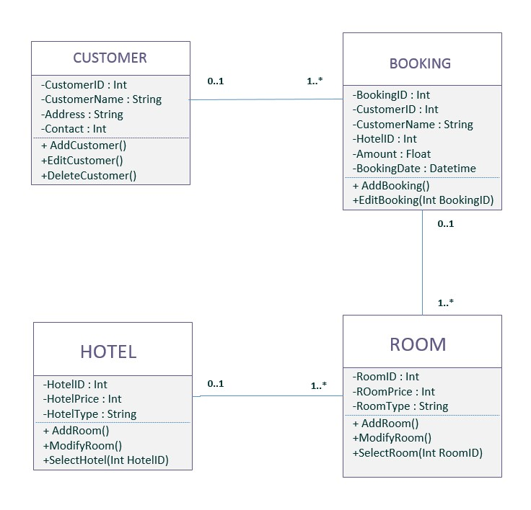

Barber Shop

Shop id: Int

Shop Price: Int

Shop type: String

Class diagram

***Use Case Diagram***

It is also called behavioural UML diagram. It gives a graphic over-view of the actors involved in a system directly. It shows how different functions needed by the actors how they are interacted.

Below is the “***USE CASE DIAGRAM***” of our new proposed system.

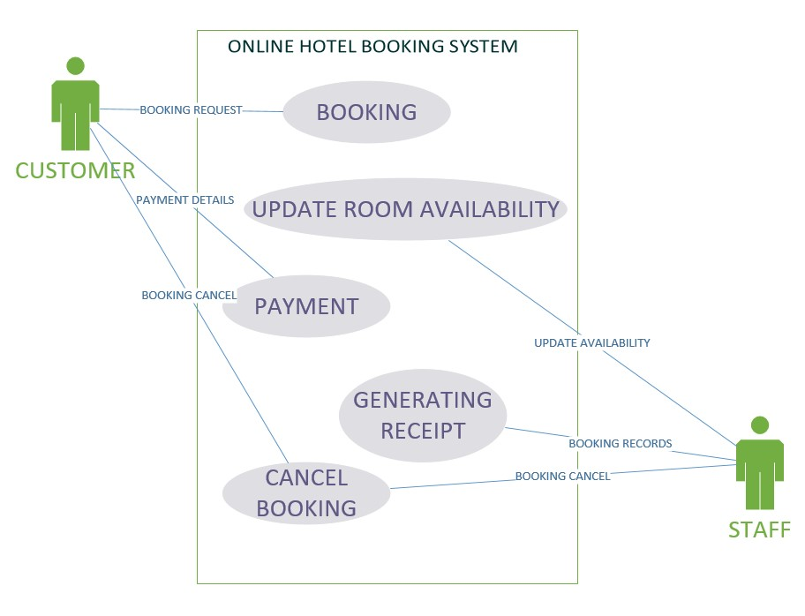

**FIGURE 3: USE CASE DIAGRAM**

|  |
| --- |
| Name : Booking |
| Actor : Customer |
| Description : Describe the process used to add a new booking |
| Successful Completion : 1. Customers can book  2. Staffs enter the customers details into the database |
| Alternative : None |
| Precondition : Customers registered as a member |
| Post condition : Slot is booked by customer |

|  |
| --- |
| Assumption : None |
| Name : Update Slot Availability |
| Actor : Staff |
| Description : Can update the availability of slot |
| Successful Completion : 1. New availability for slot booking  2. Staffs enter the available slot details into the database |
| Alternative : None |
| Precondition : Staffs update the system entering new slot availability |
| Post condition : Customers can see the latest availability of slot |
| Assumption : None |

|  |
| --- |
| Name : Payment |
| Actor : Customer |
| Description : Describe the process of payment through the system |
| Successful Completion : 1. Customers will receive the invoice  2. Staffs enter the customers payment details into database |
| Alternative : Pay after arrive into the destinations |
| Precondition : Customers registered as a member |
| Post condition : Slot is booked by customer |
| Assumption : None |

|  |
| --- |
| Name : Generating Receipt |
| Actor : Staff |
| Description : Describe the process used to generate the booking details |
| Successful Completion : 1. Staff can check the booking details  2. Staffs will keep the copy of the generated receipt |
| Alternative : None |
| Precondition : |
| Post condition : Slot is booked by customer |
| Assumption : None |

|  |
| --- |
| Name : Booking |
| Actor : Customer |
| Description : Describe the process used to add a new booking |
| Successful Completion : 1. Customers can book  2. Staffs enter the customers details into the database |
| Alternative : None |
| Precondition : Customers registered as a member |
| Post condition : Slot is booked by customer |
| Assumption : None |

**TEST PLAN**

***Test Case 001***

* **Test Title:** **E-BARBER Icon**
* **Test Procedures:** Click on the icon.
* **Test Data:** Users need to click on the icon bar.
* **Expected Result:** It will redirect to the system home page.

***Test Case 002***

* **Test Title:** **Customer & Provider Login.**
* **Test Procedures:** Type username & password.
* **Test Data:** Username & password must be in alphanumeric. Otherwise system will show error (ex. Please enter valid alphanumeric data).
* **Expected Result:** It will redirect to login page.

***Test Case 003***

* **Test Title:** **Sign Up**
* **Test Procedures:** Click ***sign up*** page.
* **Test Data:** Input customer’s information and click on the button “***SIGN UP***”.
* **Expected Result:** It will register new customer.

***Test Case 004***

* **Test Title:** **Search.**
* **Test Procedures:** Type destinations name with selecting check-in and check-out.
* **Test Data:** Valid destinations name with date.
* **Expected Result:** System will search according to customer’s choice.

***Test Case 005***

* **Test Title: Manage Booking.**
* **Test Procedures:** Click on the link “***Manage Booking***”.
* **Test Data:** ***Add***, ***Edit***, ***Del*** & ***Save*** button.
* **Expected Result:** Staffs can edit, add and Del individual customers booking records.

***Test Case 006***

* **Test Title: Username & Password**
* **Test Procedures:** Enter customers or staffs valid username (Upper Case and Lower Case) and password (Alphanumeric).
* **Test Data:** Invalid password will show the warning message (Please Enter Valid Password).
* **Expected Result:** The system will follow the validation pattern.

***Test Case 007***

* **Test Title: View Booking Cancel Button**
* **Test Procedures:** Customers need to sign in and can cancel the booking when they press cancel button.
* **Test Data:** Cancel their particular booking record.
* **Expected Result:** Will cancel their booking records from database.

***Test Case 008***

* **Test Title: Change Search**
* **Test Procedures:** Customers can change their search according to changing their check in, check out and destinations.
* **Test Data:** Click on the button “**Change Search**” from hotels availability page.
* **Expected Result:** Customers can select their new check in and check out date with destinations.

**IMPLEMENTATION**

System implementation is the most important steps in case of finalizing the approved web system. We need to justify some basic requirement (software & hardware) so that the system will work without having obligation and customers dissatisfactions.

**Software Requirement:**

* **Operating System**: Windows (XP, 7, 8, 8.1) or Mac OSX (Tiger, Leopard, Snow Leopard, Lion, Yosemite).
* **Web Browser:** Google Chrome, Internet Explorer (ver. 8 or later), Mozilla Firefox, Safari (Mac).
* **Database Management System:** MySQL, SQL Server, Microsoft Access, Oracle.
* **Web Development System:** Visual Studio 2010 or later, Adobe Dreamweaver, Notepad, and Notepad++.
* **Others:** .NET FRAMEWORK.

***Hardware Requirement***

* **RAM:** Minimum 1GB or higher.
* **HDD:** Minimum 50 GB.
* **Processor:** Intel Pentium 4 or AMD.
* **LAN:** Version 1.6.6.406(For fixing up client disconnection).

**LIMITATIONS**

Although this system will provide the booking facilities to customers, it is having some limitations. In case of enquiry when customers send their feedback through the system, it will go directly to the staff mailbox. It means the system don’t have the separate web page for checking all the customers enquiry and send reply promptly. Besides the system also don’t have the online banking (**Phone Pay, Paytm, Google Pay, UPI**) for customers.

**Documentation**

**CONCLUSION**

The system is having some benefits for customers too. In home page customers can put their email address or phone number for downloading the booking apps directly on their phone. The application will work for both OS Platform (IOS & Android). By this customers can book by using this application. Besides, customers can also book online without registering into the system. Again, customers no need to worry for payment. But for reservation they need to key in their credit card details for verification purposes. It will not charge them promptly. So, overall this system will give the customers a better user friendly environment to book online.

**REFERENCES**

**Bibliography**

Agoda.com, 2014. *Agoda.com.* [Online] Available at: http://www.agoda.com/msmy/?type=1&site_id=1415444&url=http://www.agoda.com/&tag=10c75ac0-c743-4ffe-8b015901339559ef&device=c&network=g&adid=54270519426&rand=5482813827515076520&expid=42801 52&adpos=1t1&gclid=Cj0KEQjwq52iBRDEvrC12Jnz6coBEiQA2otXAn7IruJOTl [Accessed 20 October 2014].

Booking.com, 2014. *Booking.com.* [Online]

Available at: http://www.booking.com/index.html?aid=378266;label=booking-name-

sONOsHFUDs3qkZY8eHVLqgS35420572471:pl:ta:p1:p2544,000:ac:ap1t1:neg;ws=&gclid=Cj0KEQjwq52iB RDEvrC12Jnz6coBEiQA2otXAp8sdf2xl13y5p6ad6X7mKjuGFwi8-0hZO3yvMK1P9QaAvtt8P8HAQ [Accessed 20 October 2014].

EASYTOBOOK.COM, 2014. *EASY TO BOOK.* [Online]

Available at: http://www.easytobook.com/?amu=2599051302&utm_nooverride=1 [Accessed 5 December 2014].

Expedia AU, 2014. *Expedia AU.* [Online] Available at: http://www.expedia.com.au/Hotels [Accessed 19 October 2014].

Hotel Club, 2014. *Hotel Club.* [Online]

Available at: http://www.hotelclub.com/Australia/ [Accessed 19 October 2014].

Hotels.com, n.d. *Hotels.com.* [Online] Available at:

http://www.hotels.com/?PSRC=SEMB&rffrid=sem.hcom.E5.google.003.00.01.s.kwrd=ZzZz.sEaLM1M5C.

0.51707353162.10200p829340.d.c&gclid=Cj0KEQjwq52iBRDEvrC12Jnz6coBEiQA2otXAqoAxb7bw_O4y4

24TF_D5-O9XCDcDH_OB46NcdzA14QaAkz58P8HAQ [Accessed 20 October 2014].

Marriot, 2014. *Marriot.* [Online]

Available at: http://www.marriott.com.au/default.mi [Accessed 19 October 2014].

Quickbeds, 2014. *Quickbeds.* [Online] Available at: http://www.quickbeds.com/ [Accessed 19 October 2014].